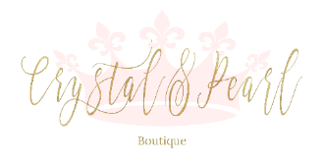
PRINCESS COLLECTION DRESSES - SIZE CHART
Age | Chest | Waist | Shoulder to waist | Waist to floor | Size of armhole | armpit to floor
1 yrs | 46cm | 45cm |  |  |  | 70cm
2yrs | 53cm | 52cm | 23 | 55cm
3yrs | 55cm | 53cm | 23cm | 60cm
4yrs | 57cm | 54cm | 24 | 64cm
5yrs | 59cm | 55cm | 24.5cm | 69cm
6yrs | 61cm | 56cm | 26cm | 76cm
7yrs | 63cm | 58cm | 28 | 79cm
8yrs | 66cm | 59cm | 28 | 87cm
9yrs standard size | 69cm | 61cm | 29 | 88cm
9 (plus size) | 78cm | 71 cm | 29 | 88cm | 40cm | N/A
10yrs standard size | 72cm | 62cm | 30 | 90cm
10 (plus size) | 86 | 76cm | 30 | 90cm | 40cm | N/A
11yrs | 75cm | 63cm | 31 | 95cm | 35cm
12yrs | 79cm | 64cm | 31 | 98cm | 35cm

